

**CSE488: Big Data Analytics**

**[SPRING 2023]**

**Assignment**

**Online Assignment Lab 6**

**Submitted by:**

Student ID: Mujahidul Islam

Student Name: 2019-2-60-072

1 no:

Input

Executing Command Prompt:

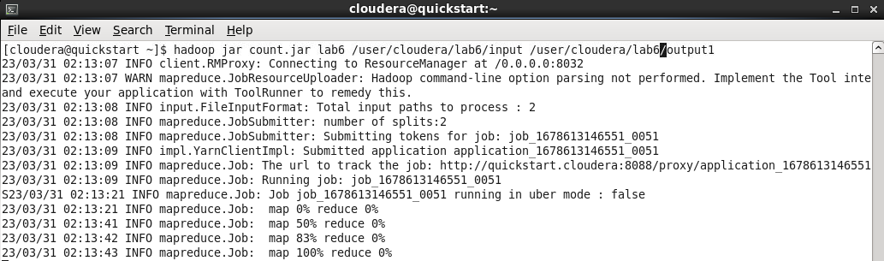

Output:

2 No

Code:

Input file:

Executing Command Prompt:

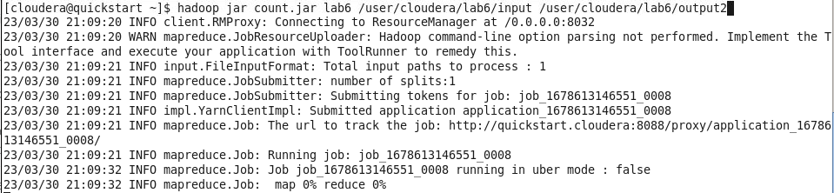

Output:

3 No

Code:

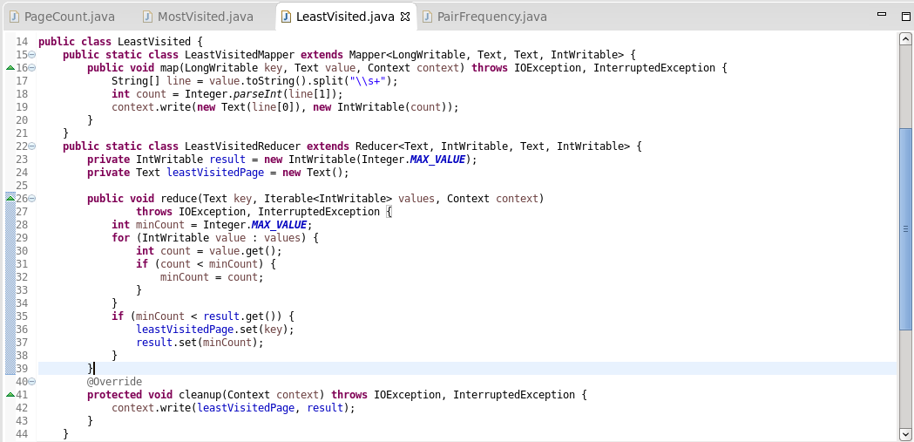

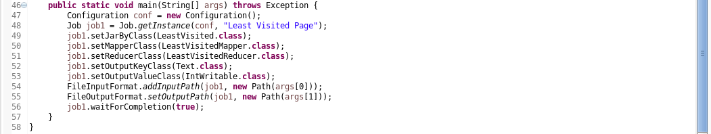

Input:

Executing Command Prompt:

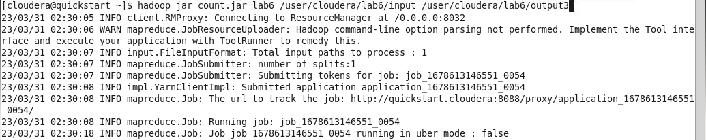

Output:

4 No

Code:

Input:

Output:

